**What is it**?

**MD”A” Convention**

May 21-24, 2015

Ambassador Resort & Hotel, Kingston

41st Annual Multiple District convention where Lions from 10 districts gather to celebrate and share success from the past Lion’s year.

**Why Attend…**

* **You can decide to take in all or just some of the events – many of them included in the low $25.00 registration fee.**
* **Browse the pin trader’s tables to enjoy the Lions history or maybe make a trade or two.**
* **The Stew O’Brien Golf Tournament will be held Thursday morning @ 8:00 am. Cost is $55.00 including golf, cart, and food.**
* **Bring the kids and enjoy the Ambassador Hotel swimming pool and water slide. Better still join them.**
* **Eat in at the hotel restaurant or enjoy the many local food venues.**
* **The hotel atrium area will be the vendor location. There will be articles for sale, learn about the Lion’s charities, and other MD”A” activities.**
* **Meet other Lions & Lioness to share ideas and success stories.**
* **Friday night we will be entertained with a group called Dick Miller & Peter Lovett with English pub style food.**
* **Our International guest will be International Director Larry Dicus and Lion Jane from California.**

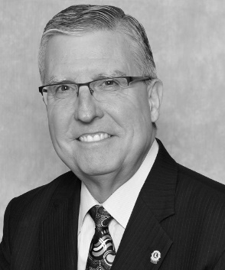

* **Join chair Lion John Harvey at a Youth Opportunities Luncheon. Learn how you can get involved with the youth in our communities.**
* **Attend the Council meeting on Friday morning then enjoy the Opening ceremonies on Friday afternoon.**
* **Hear reports from the Multiple District chairs on how your donations are being spent and the impact the programs have on the recipients.**
* **Your Global Leadership and Membership teams will be presenting seminars on Saturday morning and afternoon.**
* **Exercise your club’s right to vote on constitution & By-law changes.**
* **On Saturday afternoon, District A5 will be promoting next year’s convention. MDA will be endorsing an International Director for 2017 at this convention. You’ll want to be in Kingston to register for the 2016 convention as rooms in North Bay will fill up fast.**
* **Attend the Memorial Service on Sunday morning to honour the Lions that served their communities for many years.**
* **Be at the closing session to see your incoming District Governor be introduced to the Lions of MDA.**

**How do you Register?...**

* Go to the MDA web site mdalions.org
* Click on 2015 convention registration.
* All room bookings will be with the Ambassador Resort and hotel. Contact info is on the MDA Webpage.
* Visit [www.kingstonlobby.com](http://www.kingstonlobby.com)

Look at “***What to do in Kingston before and after the convention”.***